Food Management System

Use-Case-Realization Specification: Delete Product

Version <1.0>

Revision History

|  |  |  |  |
| --- | --- | --- | --- |
| **Date** | **Version** | **Description** | **Author** |
| <24/12/2020> | <1.1> | Final Draft | Nguyen Thi Ngoc Anh |

Table of Contents

1. Introduction 2

1.1 Purpose 2

1.2 Scope 2

1.3 Definitions, Acronyms, and Abbreviations 2

1.4 References 2

1.5 Overview 2

2. Flow of Events—Design 2

3. Derived Requirements 2

Use-Case-Realization Specification: Delete Product

# Introduction

## Purpose

This document describes how the Delete Product Use-Case is realized within the design model, in terms of collaborating objects.

## Scope

This document applies to the Food Management System which will be developed by our group – SAPAssDWill.

## Definitions, Acronyms, and Abbreviations

User – a person who use the system, can be customer or employee.

Admin – administrator

## References

None.

## Overview

In the following section, Use-Case Realization Specification of the Delete Product Use-Case of the Food Management System is provided in detail. The first section is a textual description of the Use-Case specification. The following section contains diagrams (sequence and collaboration diagrams) describing how the use case is realized in terms of collaborating objects. The third section includes class diagrams with relationships that participate in the realization of the use case. The last section is an analysis of all requirements, such as non-functional requirements, on the use-case realization that are not considered in the design model, but that need to be taken care of during implementation.

# Flow of Events—Design

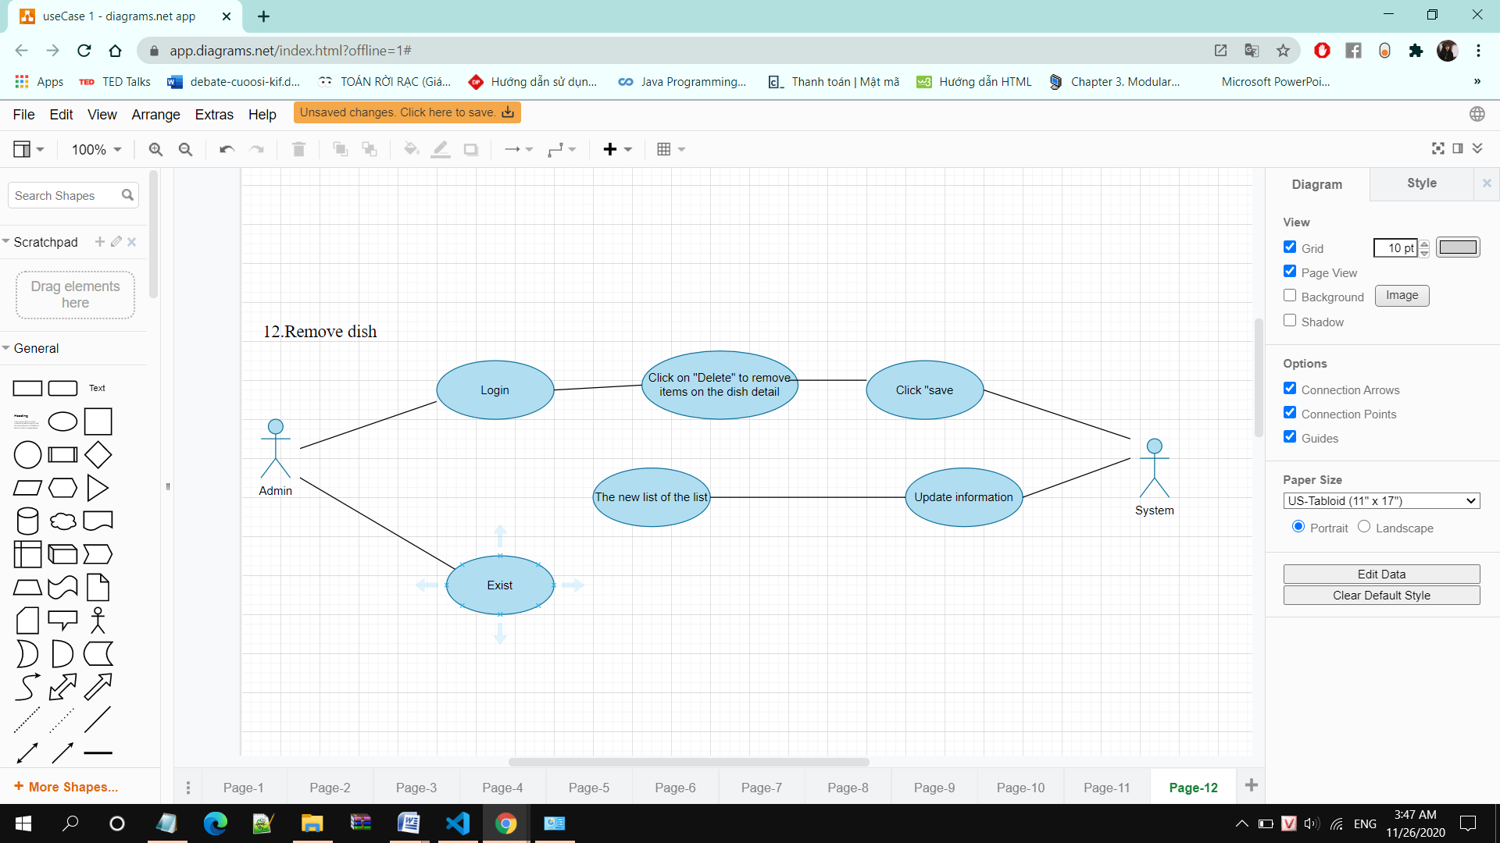

|  |  |
| --- | --- |
| Use Case | Remove dishes |
| Actors | Admin |
| Description | Admin delete dishes |
| Triggers | Admin click on Delete dishes on dish detail |
| Pre-conditions | Admin login successfully |
| Post-conditions | Admin return main interface screen and dishes removed successfully |
| Main Event Flow | 1. Adminclick on “Delete” on own dish list interface 2. The system displays a message confirming deletion 3. Admin press delete 4. The system processes and displays deletion successfully |

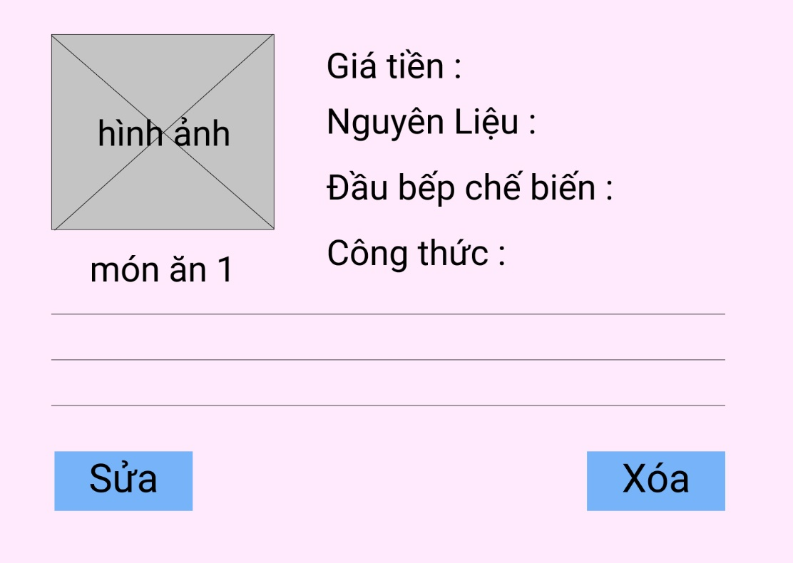

Interface Edit / Delete

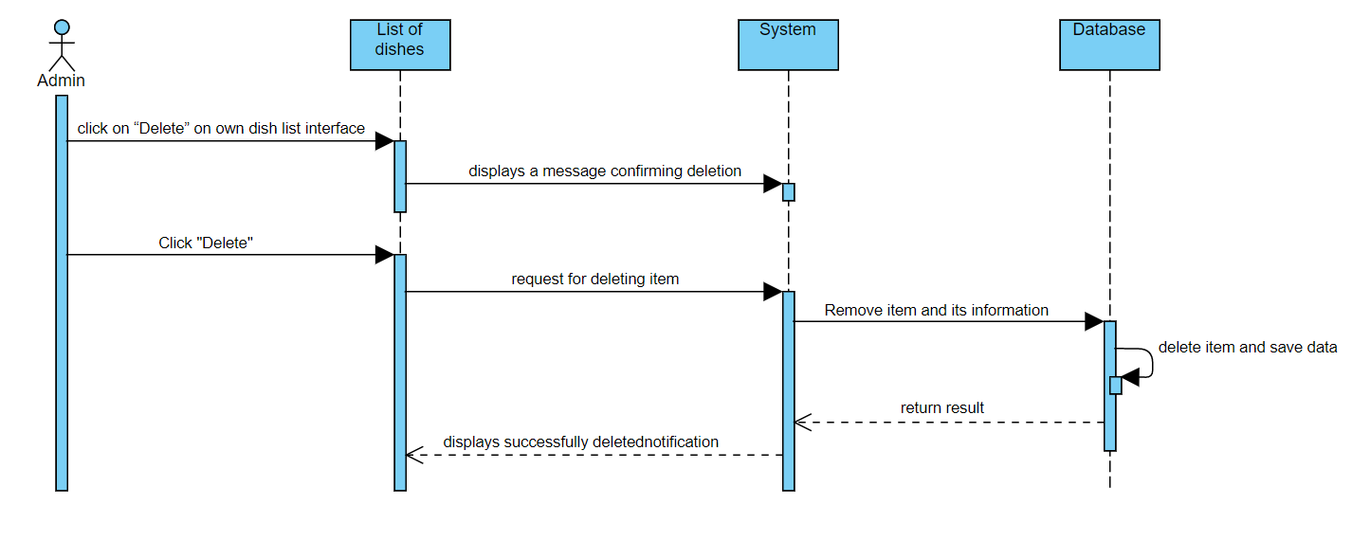

# Derived Requirements

None.